Mathematics and Music
Hsiu-Hui Peng Chen

There are numerous researches probing the relationship between the mathematics and music. The interplay between the two subjects has also been a common topic in many science fair projects and student essays as well. A popular conjecture is that the frequent, rhythmic touches between finger tips and the piano keyboard produce a sequence of mild, pulsating impulses that transmit through the nerve system to stimulate the intellectual growth and development of human brains. As a piano teacher, I have always been intrigued by the magical connection bridging these two very different realms of disciplines. Since I am not a music or mathematics researcher, I do not have a systematic data to support the claims. What I can offer in this article is based on my personal observation on the developments of many piano students in my twenty-five years of piano teaching experience. It is interesting and fascinating.

Music and math have always been an integral part of my daily life, as a child, a college student, and even now as a mother of two. I began giving private piano lessons while I was still a college student, and I have continued to learn from teaching numerous piano students. This experience offers me a unique opportunity to observe up close my piano students’ developments in music as well as in academics. The ages of my students range from the slight age of 3 to the ripe age of 50. The bulk of my students are in grade school. Many of them struggle with surges of teen-age hormones, unstable emotions, parents and peer pressures. The process of mastering a complicated piano piece can be stressful, but playing a well-versed piano music tranquilizes the fretting mood and helps maintain a peaceful state of mind. The topic of my interest focuses on the effects of piano learning on young children’s (ages 3-12) mathematics development. The discussions will be focused on the three areas as follows:

- How does a solid math education support a student’s music development?
- How does music in a student’s life support his mathematic achievement?
- What is the connection between math and music?

How does a solid math education support a student’s music development?

There have been a lot of researches and many theories attempting to prove that learning an instrument in early childhood helps stimulate a person’s intellectual growth and development. Doctors and nurses around the world are beginning to suggest the parents of newborns to play classical music for the baby during the feeding and before bed, in belief that it will stimulate certain portions of the human brain. As a music teacher, I pay particular attention to when children can move to the next level of actively playing music as opposed to passively listening to it.

When is a child ready for music lessons? For example, in my own experience, a three-year-old child lacks the attention span of an older child of, say, 10 years of age. The young child is able to focus for a maximum of half an hour with his teacher before getting distracted. For children this young, I begin by teaching them the concept of their five fingers: the number 1, 2, 3, 4, and 5.We have five fingers on each hand, and we use them everyday for daily tasks such as picking up food, making a fist, opening doors, etc. We depend on our hands for a lot of menial tasks. Music requires a higher level of attention to the fiver fingers, and piano is especially demanding. Piano players need to use both hands and the player must follow the fingerings depicted on the music sheet. Pianists need to have a precise control of their fingers, for piano requires the use of both hands, all ten fingers at all times. Once the student advances to the point of playing music that requires both hands, it is very important that, no matter how young the child is, I enforce the numbers 1, 2, 3, 4 and 5 to correspond to thumb, index, middle, ring, and pinky fingers respectively, Figure A [1]. I require them to memorize the relation between the fingers and their respective numbers until it nearly becomes a second nature to them. It is only after I see that the student has firmly grasped this fundamental idea that I begin to teach them to read the notes on music sheets.

It’s hard to over-emphasize the importance of the fiver finger pattern, especially for those young beginners. Figure B depicts how to use the simple method of finger numbering to play the melody formulated in a formal music sheet shown in Figure C [1]. I often use such diagrams to help young students understand and reinforce the concept that relates numbers to their fingers.

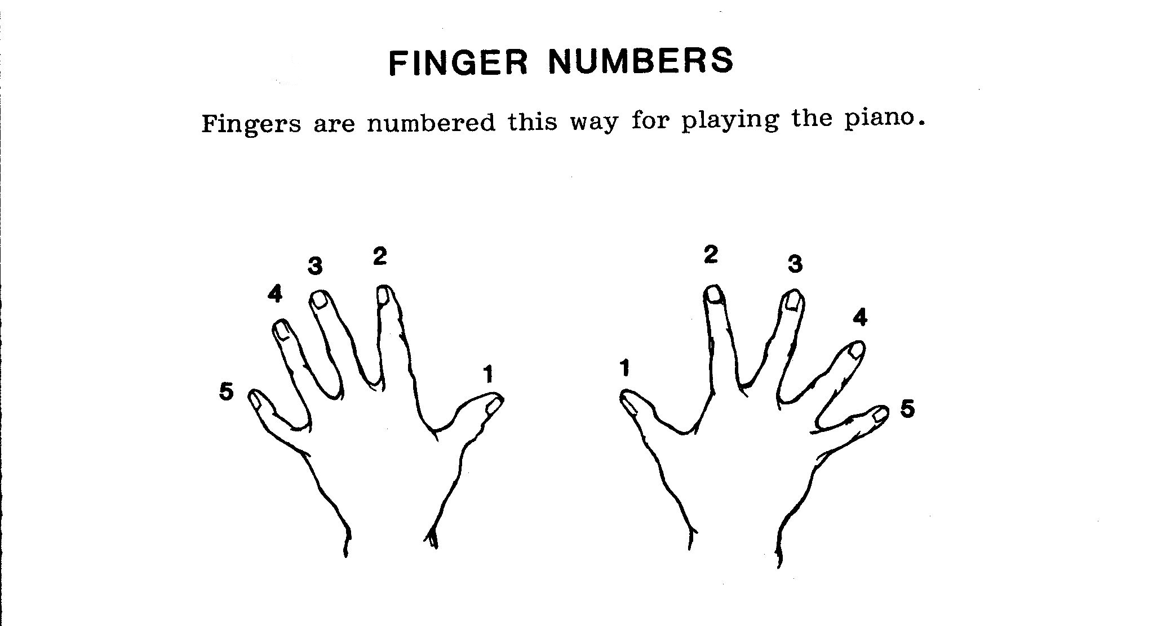
Figure A

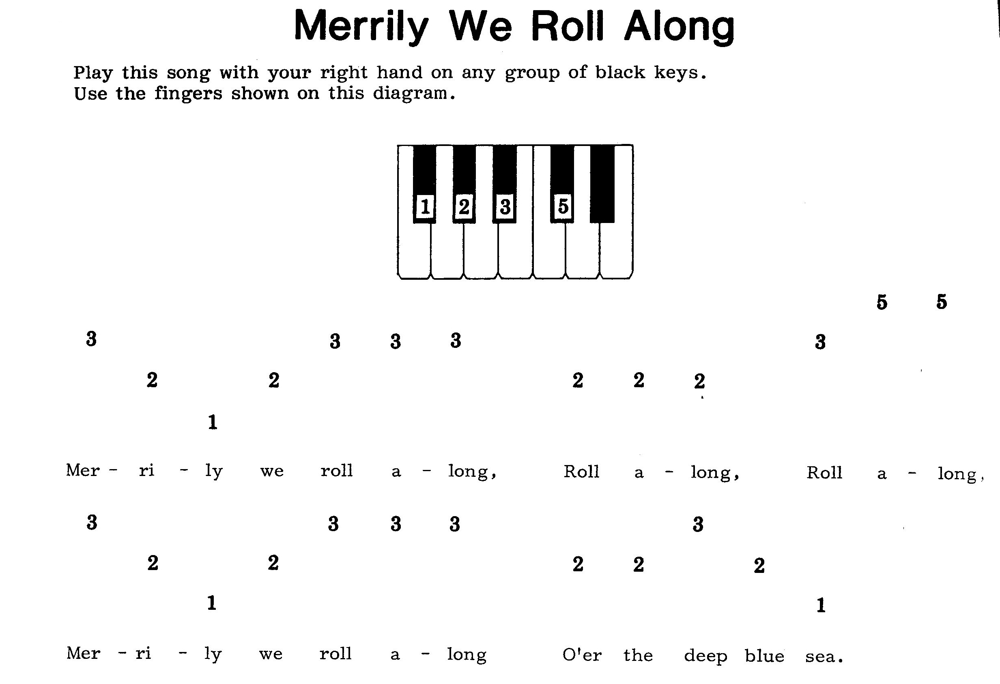
Figure B
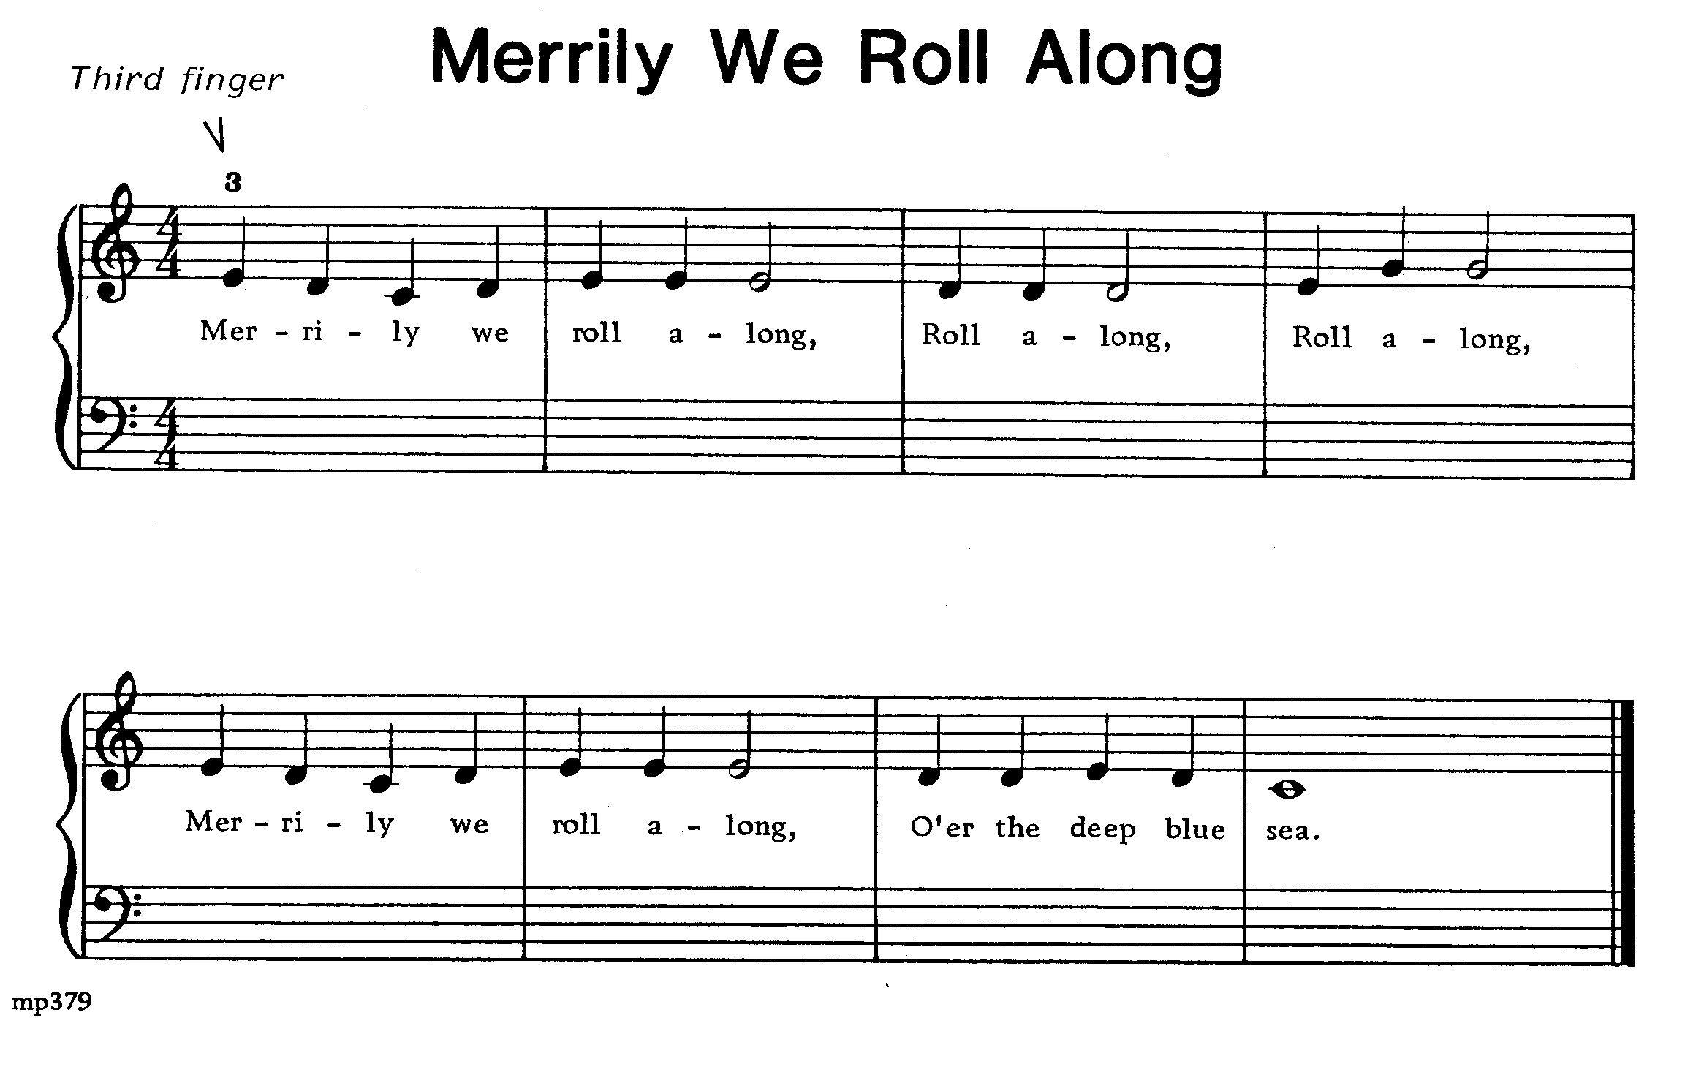
Figure C

In addition to emphasizing the numerical order of fingers, as a piano teacher, I also have to explain many related math concepts to my students regardless of their ages. In order to prepare them to meet the music challenges ahead, I have to build a math foundation for them as a sustaining system, even if they are too young to make a proper sense out of math. The time signature of the music is always depicted on the very left side of each staff. For example,

3 → 3 beats total in a measure
4 → the quarter note will have a value of one beat

6 → 6 beats total in a measure
8 → the 8th note will have the value of one beat

i.e, 2 eighths = 1 quarter

So, in Group A, 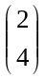 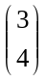 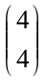 counts as 1 beat, and one and a half beats, two beats, and three beats.
But, in Group B, 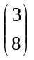 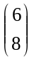 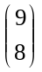 counts as 1 beat, two beats, three beats, and four beats.

Compared Group B with Group A, we can see that each note in Group B receives double beats. This concept is actually a multiplication in disguise. As demonstrated in many children's learning results, students are better oriented to mathematical concepts if they are frequently exposed to practical examples, which have been methodically incorporated into their daily learning. Five finger pattern and various beat counting methods are two of such examples in piano music. Quite often we see that children who take piano lessons prior to grade school often have an advantage over their peers who have never previously been exposed to such mathematical concepts. And once they reach the 1st or 2nd grade, they will have a much easier time picking up elementary arithmetic skills.

Basic mathematic concepts, such as addition and multiplication, are instrumental for music learning. This is not only true for the young beginners but for intermediate and advanced pianists as well. In fact, it is even more important for the more advanced students to have a sounder mathematic background to achieve an accurate, flawless performance. Most students have little trouble playing notes with even numbered ratios, for example, in what I like to call “2 match 1” (quarter notes on one hand, 8th on the other hand), or “4 match 2” (16th notes on one hand, 8th notes on the other). However, some pieces call for triplets on the one hand, and 8th notes on the other hand. I call this “3 against 2”, and these types of music pieces demand infinitely more concentration to be played accurately. As the performance level gets higher, students inevitably encounter music literature that requires more challenging two-hand coordination such as "5 against 3," so on and so forth. Examples of more complicated combinations are given below:

- Arabesque in E Major (by Debussy) [2]

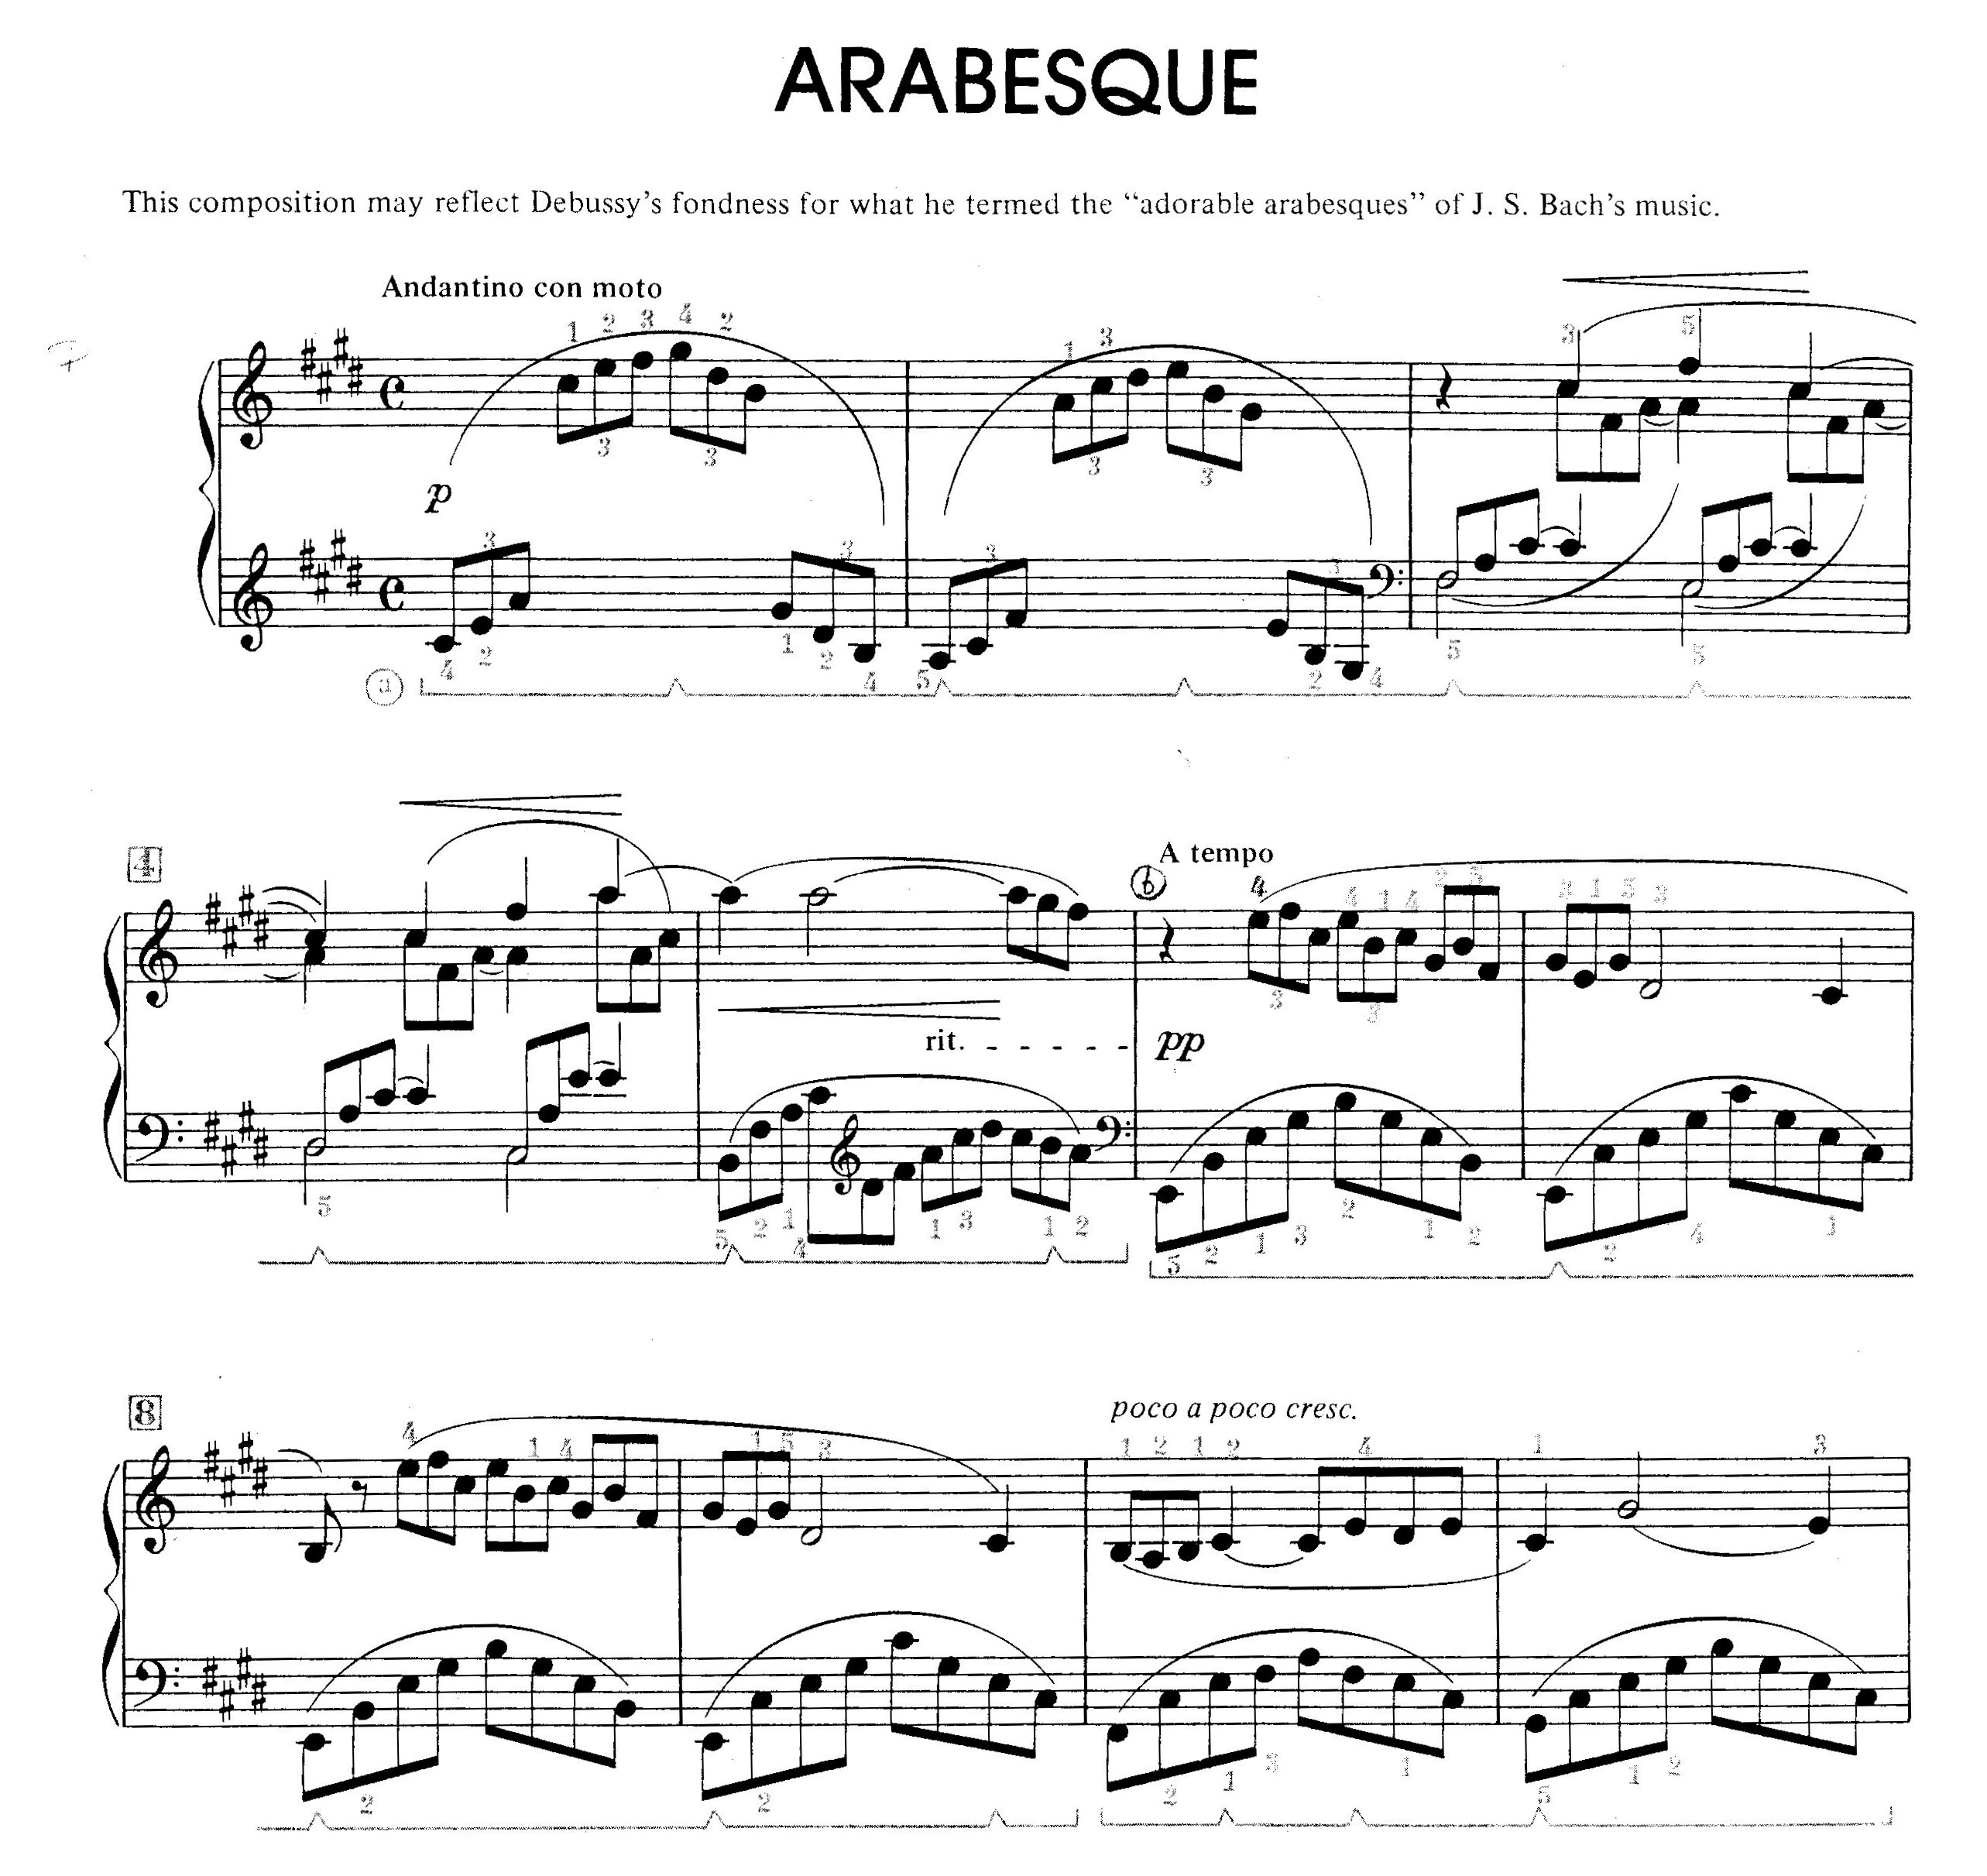

Figure D

This piece of music, Figure D, begins with a single hand triplet. At measure 6 the right hand (upper clef) contains triplets and the left hand builds up by 8th notes, giving the student some three-against-two action.

- Clair de Lune (by Debussy) [2]
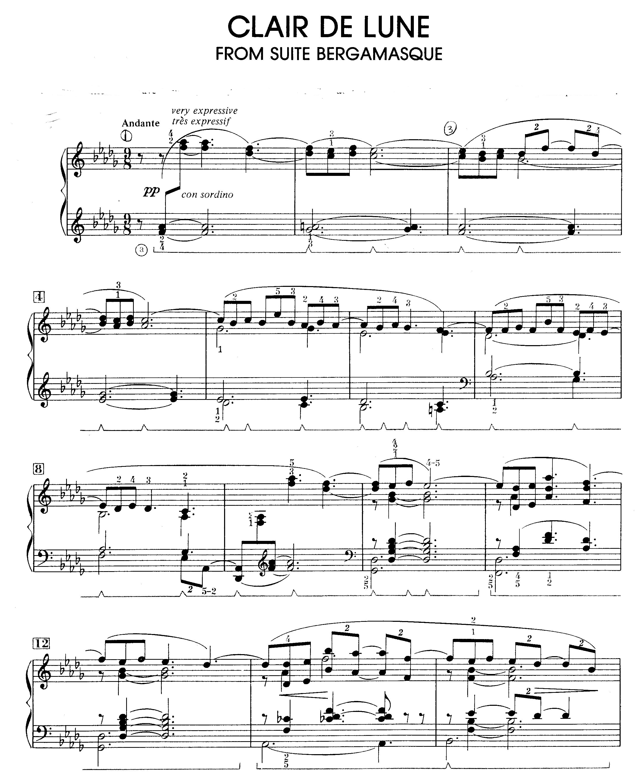

Figure E

This piece, Figure E, has a time signature of 9/8 (the 8th note gets one beat and there are 9 beats total in a measure). This key signature makes it difficult to count the beats as 9 beats per bar, so, instead, we count it in sets of 3 per measure to make it more logical for the musician. This approach enables a student to interpret the music as a piece of music with ¾ times signature but at a slower tempo.

- Fandaisie- Impromptu (by Chopin) Op. 66 [3]
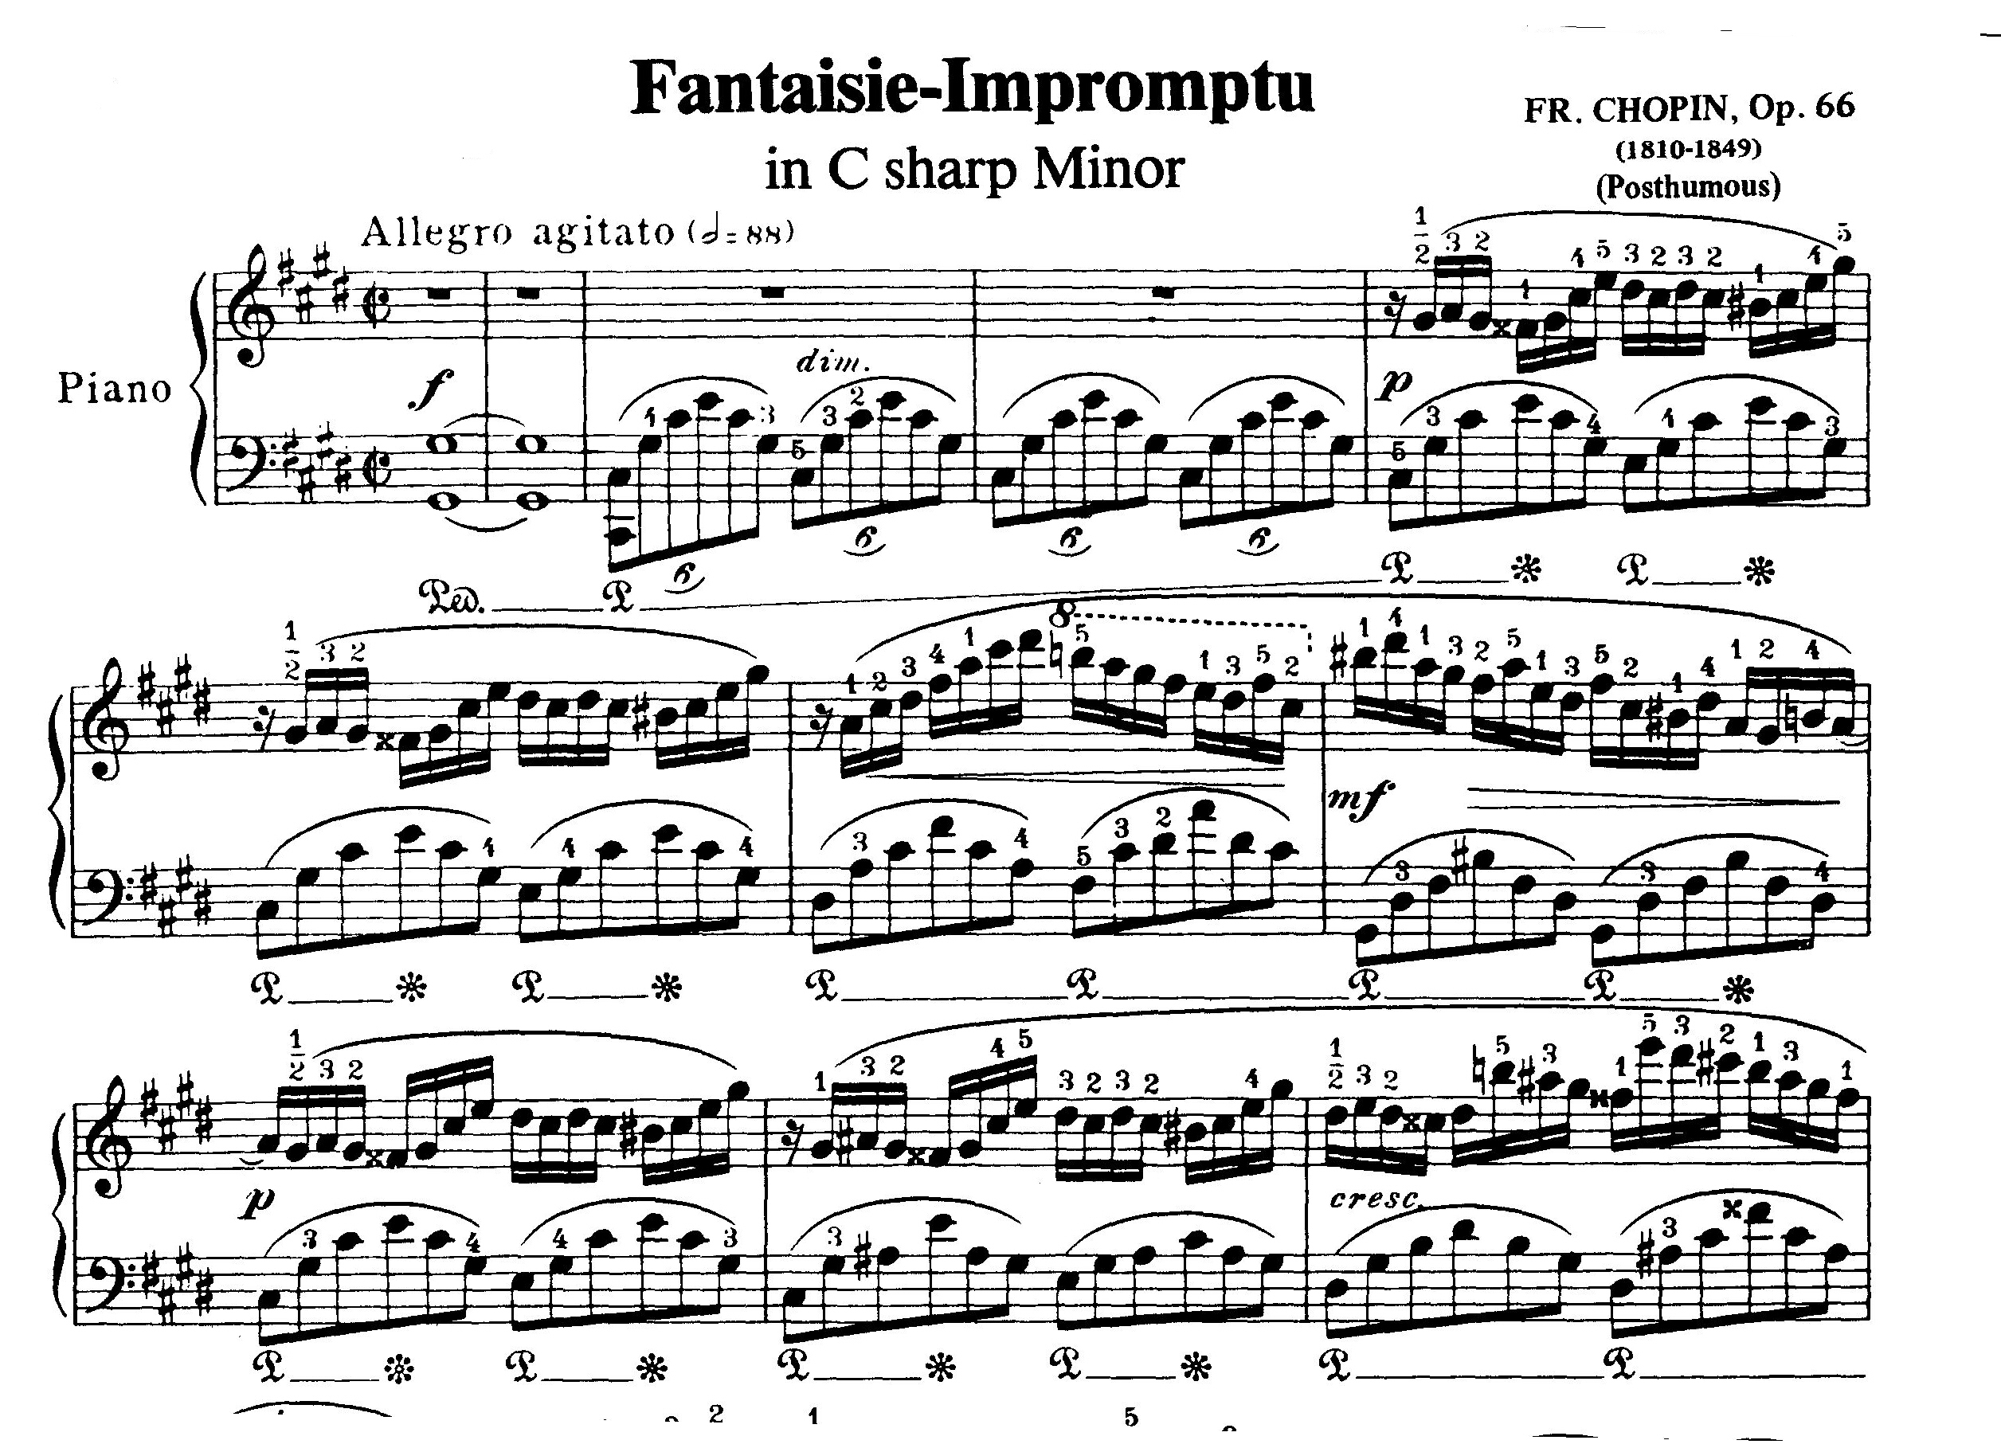
Figure F

This music, Figure F, shows the time signature of ￠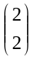 which means that we use as one count; that is, note values are all cut in half. The left hand part is built up by
6
Thus, the left hand part which is composed of six 8th notes is now counted as 1 half note. The right hand part is built up by eight 16th notes, which are also counted as 1 half note. Essentially, for every note played by the left hand, the right hand has to match it by playing 8 evenly-spaced 16th notes. And this is no simple task. I find it helpful if the students start off by playing the rhythm as if it were 4/4 and try to match four 16th notes on the right hand to three 8th notes on the left hand (4-against-3). Once the students can do this evenly, the tempo is then gradually increased until the rhythm can be accurately played in the 2/2 time signature. Simplifying the key signature is a very powerful way to help the student master the technique and structure of a difficult music piece composed with a complex time signature.

- Nocturnes Op. 9 No. 1 (by Chopin) [4]

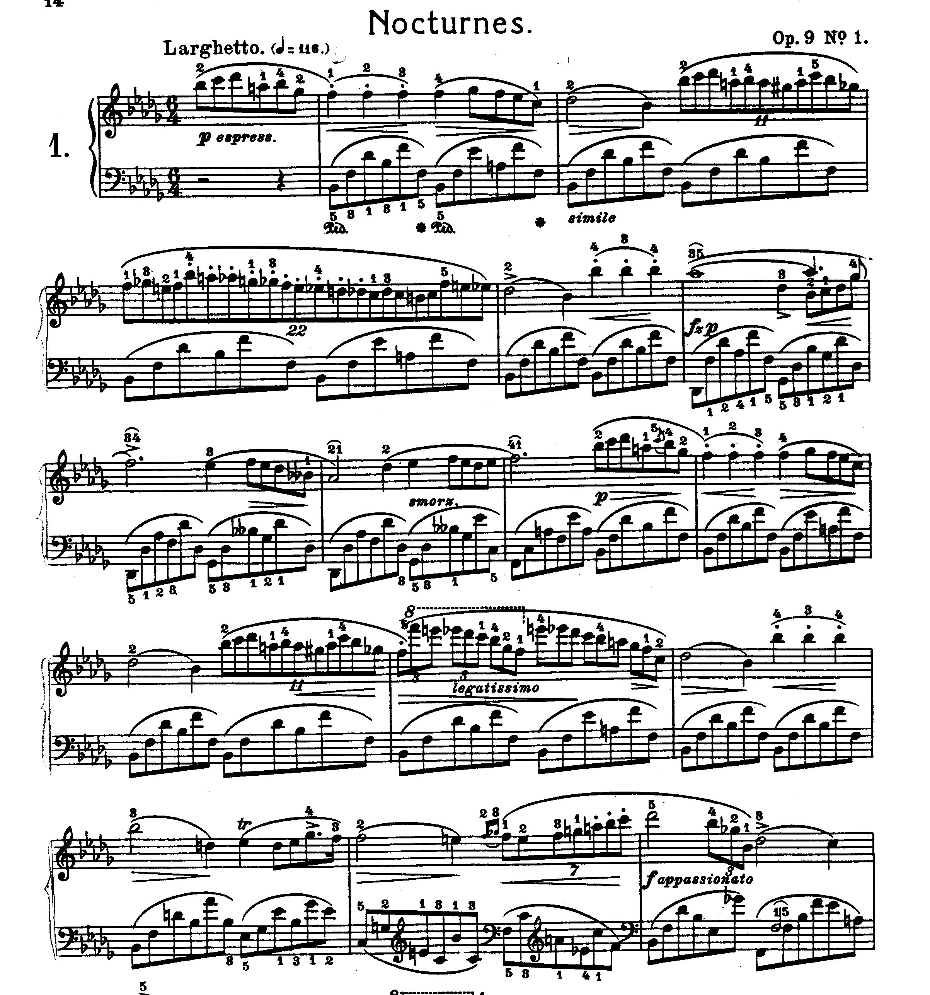
Figure G

Let's examine the 2nd measure in Figure G first. The right hand contains eleven 8th notes which are played throughout the duration of three beats, while the left hand contains six 8th notes which are also played throughout a total of three beats. Now, let's try some simple math: if we divide 11 by 6, the result is 1.83333. Students will never go far if they really try to count the beat by following the irrational number. The knack is that students should be able to use their well-established yet simple math concepts, aided by sufficient practices to build up the required muscle memory, which in turn trains our brain to develop a high degree of balance for both hands to meet such a challenge.

The above four illustrations are examples, on the technical side, to explain how math helps students better dissect, understand, and interpret complex music pieces. This is especially important for pianists who solely rely on counting the beats to achieve a perfect coordination of both hands. On my collective observation over groups of students, I also notice an interesting phenomenon to share with interested readers.

The middle and high schools in Ann Arbor School District annually participate in a well-organized “Solo & Ensemble” event, in which band and orchestra students are given an opportunity to perform to professional musicians and receive a rating of their achievements in a scale of 1 to 5 (1 being excellent, 5 being below par). Students who receive the 1st division rating are qualified to proceed to the State Semi-finals, a rare honor that motivates aspiring students across Michigan to participate. I’ve noticed that many students who are qualified to enter the State level competition and earn recognitions are those who have also demonstrated rather satisfactory math ability in school.

How does music support math?

The process of practicing and learning a piece of music itself helps a student improve his or her math skills. Studies have shown that music appreciation helps people relax or soothe nervous tensions arising from work, school, relationships etc. in our daily lives. While listening music is relaxing, studying music as a performing musician requires an active participation. When a student reads piano music, they have to follow the notes, reading chords up and down the music staff, as well as following the scale fingerings- all at the same time. All these functions require a good memory, subtle hand-eye coordination, and an almost indefinable quality known as “touch.” Practicing piano requires a student to exercise his / her muscles and brain memory to its full potential.

Mastering mathematics requires logic, understanding and organization of materials. It also requires the ability to quickly relate the new concepts to the organized data structure already built upon what one has learned before. Music takes this requirement to a far higher level, especially when one performs from his memory in front of judges or appreciating audience. If a student encounters an unexpected situation that makes him momentarily forget the repertoire in a recital performance, but if he has sufficient daily practices, it will provide him with automatic muscle memory to keep up the flow of the performance. Once students have developed the ability and logic to build up the notes and repertoires, with the aid of simple arithmetic functions and simultaneous hand-eye coordination, their ability to master more advanced math concepts will come along more naturally. Given below are three of many real cases that I have followed up in my own studio.

Case 1: Lucy Huang is a 10 year old girl. She came to my studio when she was 9 years old. She started her piano lessons relatively late compared with other students. When she first started her lesson, I noticed that she struggled, having hard time reading the music. Her learning curve was not as satisfactory as those of my other students. However, over the course of six months, she consistently practiced her assignments (one hour a day, every day) which encompassed finger patterns of different levels of difficulties. I observed a marked improvement in her level of attention during the lessons as well as her attention span. Learning new music came more naturally as time went on. Later when I mentioned my observation to Lucy, she told me that recently, she felt very comfortable with her math learning in class. It took less effort for her to understand calculation methods and grasp with new functional concepts.

Case 2: I have taught many students in the past 25 years. One student stands out in particular. Michelle Mei, now 15 years of age, began her lessons with me when she was 8 years old. Her parents and I would chat over the phone on a regular basis about Michelle’s progress as a pianist. At times, her father would mention that she had some difficulties in math, namely, in understanding new concepts and using old concepts to support new ones. Michelle has always loved music, and her father told me that he hoped that maybe learning music would stimulate her brain and help her attain higher levels of academic achievement as well. For 7 years, Michelle took lessons weekly and faithfully practiced all her assignments. Her learning curve was about average during her first year with me. Gradually, she became more and more self-motivated and the time she spent on piano practices increased to about 2-3 hours a day. It became very noticeable to her parents and to me that her recitation skills in many recitals had increased dramatically. And it wasn’t long before Michelle’s mother told me that Michelle’s math grades showed marked improvement, so did her Spanish and English grades. All the while Michelle had also worked through and memorized a phenomenal amount of music repertoires in the past three years. I believe that her persistent effort put forth in music helped her develop a substantial capability in logical reasoning and in information organization, which reflect on her laudable academic performance. Currently, she is a sophomore in high school and is stellar in both her music and academic performances.

Case 3: Robin He is another distinctive example showing osmosis effect of music on a child’s development over time. Robin started his piano lesson at the age of 6. His parents observed that his math capability improved continuously alongside his piano skills. Three years later, he won the first prize of North American Kumon math competition in the 4th-grade category. In the years that followed, Robin continued to win the second prize in the 6th grade, and the first prize in 2005 when he was in the 7th grade. All these honors came with encouraging amounts of scholarship. His parents strongly believe that practicing piano produces a very favorable effect that helps Robin’s math development.

Schools across Ann Arbor District actively promote a very popular activity known as “Math Counts”, which is an encouraging program that uses a series of competitions with other schools to motivate students in mathematic learning. Students have to distinct themselves through many rounds of competition in order to proceed to Semi-final or Final. It’s fascinating to note that a majority of qualified students, representing my neighborhood Clague Middle School to the Regional Final, take and practice piano lessons simultaneously. This phenomenon seems to suggest to certain degree that music does help students develop a stronger mathematics capability.

What is the connection between math and music?

Many timeless pieces such as Beethoven’s 1st Symphony, Chopin’s Nocturnes, Mozart’s Sonatas, were composed with a great deal of attention to mathematical symmetry and harmony. I teach my students to study the structure of the music thoroughly. Each piece has a certain frequency of flow, the number of beats in a measure, which note gets the beat, when one should press or lift the foot pedal, when it is appropriate to break a slur, how many notes should be played in a set of trills etc. Simply looking at the music itself and playing the notes will not take students anywhere. It is in studying the structure of the notes from a mathematical standpoint that helps students comprehend the sophisticated rhythmic coordination to fully unlock the composers’ musical talents embedded in the music notes.

Finally, I like to take this opportunity to share my personal experience in music and math. Born in 1957, I was the youngest in a typical middle class family of six siblings. My father was an electrical technician in a fertilizer factory. Though his meager salary at that time could barely scratch a living for a family of 8, he strongly believed that a good education was a sure ticket to a better life ahead for his children. He did odd jobs after his regular work to eke out our family living and to supplement children’s education spending. Though being the youngest, I understood the harsh conditions my parents faced. I worked hard and earnest from grade school to high school. I always excelled in math and sciences. All those obscure concepts and logics seemed to come to me very naturally, and I seemed to be cut out for a career in science or engineering. However, learning how to play piano had always been a dream that I wanted to realize, a dream nearly next to impossible to actualize for a kid from such a humble family. It is in my continuous demonstration of a superb academic performance and an unquenchable passion in piano that finally persuaded my parents to support my piano study. I kept up my dream to myself and my promise to my parents throughout my middle school and high school years. I earned the top honor in my academic achievement when I graduated from Taipei First Girls’ High School. Nonetheless, piano had always been my true love. No matter how challenging the situations were, never had I thought of giving up my piano practicing, even during the most critical year in high school when I (as well as all my fellow students) was faced with the tremendous pressure of college entrance examination.

For a long stretch of time, I always thought that the reason of my excellent academic achievements in all my middle and high school years was because I worked extra hard to keep up lest my parents withdraw their support of my piano learning. However, I remember vividly that my academic performance showed marked improvement after I took my private piano lesson. After years of working with my piano students, I came to realize that quite possibly, my ability in math reasoning and logic had been unknowingly enhanced by my music training and piano practice. Looking back on where I had journeyed in my music and academic endeavors, I deeply believe that my mathematical training helped me analyze, understand the music structures, which enabled me to overcome many technical barriers in building up my piano skills. It is also my mathematical capabilities that enable me to come up with many creative methods to help my students glide through those rough spots on the road of piano learning. It is very gratifying to see that many of my students already surpass my piano attainments when I was in their ages.

In conclusion, it is my personal experience that practicing music helps young children develop a better ability in acquiring mathematical concepts, and that people who have a sound foundation of mathematics have a high level of advantage in learning music skills.

References
- Clark, M. E., “Nyklas Complete Piano Course, Book One,” Nyclas Music Press.
- “Arabesque in E Major” and “Clair de Lune,” by Debussy, Alfred Publisher.
- “Fandaisie- Impromptu,” by Chopin, Op. 66, Carl Ficher Inc.
- “Nocturnes Op. 9 No. 1,” by Chopin, 全音出版社, Taiwan.

